**Using intra-microgel crosslinking to control the mechanical properties of doubly crosslinked microgels**

Zhengxing Cui*a*, Wenkai Wang*a*, Melody Obeng*a*, Mu Chen*a*, Shanglin Wu*a*,

Ian Kinloch*a* and Brian R. Saunders*a*,*\**

*aSchool of Materials, The University of Manchester, MSS Tower, Manchester, M13 9PL, U.K.*

**ABSTRACT**

Microgels (MGs) are crosslinked polymer particles that swell when the pH approaches the p*Ka* of the constituent polymer. Our earlier work showed that concentrated MG dispersions can be covalently interlinked to form macroscopic hydrogels, which are termed doubly crosslinked microgels (DX MGs). Here, we study for the first time the effects of intra-MG crosslinking on the swelling of the MGs and the mechanical properties of the DX MGs. The MGs were synthesised by emulsion copolymerisation of ethyl acrylate (EA) methacrylic acid (MAA) and divinylbenzene (DVB). The latter was a crosslinking monomer. For comparison, MGs were prepared where DVB was replaced by either 1,4-butanediol diacrylate (BDDA) or a 1:1 mixture of both DVB and BDDA. The MG swelling behaviours were studied by dynamic light scattering; whereas, the DX MG mechanical properties were studied by dynamic rheology and uniaxial compression measurements. Inclusion of DVB within the MGs resulted in both highly swelling MGs and highly ductile DX MGs. The average strain-at-break value for the DVB-containing DX MGs was 76 % which represents the highest value yet reported for a DX MG prepared using commercially available monomers. It was also shown that good tuneability of the DX MG properties could be obtained simply by controlling the DVB and BDDA contents within the MG particles. Analysis of the swelling and compression data enabled relationships between the volume-swelling ratio of the MGs and either the modulus or strain-at-break values for the DX MGs. These relationships also applied to a DVB-free system prepared with a low BDDA content. An interesting conclusion from this study is that the DX MGs can be thought of mechanically as macroscopic MG particles. The results of this study provide design tools for improving DX MG ductility and hence increasing the range of potential applications for this new class of hydrogel.

**INTRODUCTION**

Hydrogels are swollen polymer networks with properties that are largely controlled by the number-density of elastically effective chains1. They are attracting great interest for biomaterial applications2 such as drug delivery3, regenerative medicine4, biosensors5, biomedical devices6 and soft tissue engineering7, 8. This interest is driven by their property similarities with native extracellular matrix9. Conventional hydrogels contain an inhomogeneous distribution of elastically effective chains and lack efficient energy dissipation mechanisms. Consequently, they are relatively brittle5. To solve this problem, new gels have been designed including double network gels10, nanocomposites hydrogels11, and ionic crosslinking gels12, or reinforced gels containing microgels (MGs) or carbon fillers13-15. MG particles are crosslinked polymer colloids that swell in a good solvent or when the pH approaches their *pKa*16-18. New gels with enhanced strength and toughness open pathways to high performance applications such as load-bearing tissues and medical sealants19, 20. A common limitation for many hydrogels is that they are constructed by polymerisation of small molecule monomers. This method can limit their potential for biomaterial applications because such preparations may not be suitable for *in* *vivo* use. We established an alternative approach to hydrogel construction that used preformed MG particles as macro-crosslinkers and hydrogel building blocks21. The hydrogels are termed doubly crosslinked microgels (DX MGs). When compared to high ductility gels such as double network hydrogels22, our previous DX MGs were relatively brittle21, 23. The motivation for this study was to establish a simple and versatile method for improving DX MG ductility. This led to two hypotheses that underpin the present work. The first was that the ductility of the MG building blocks and DX MGs were intimately related. The second was that the use of a crosslinker that was structurally different to the primary monomer that comprised the MGs would result in more swellable (and ductile) particles because the crosslinker would be less efficiently distributed throughout the MG. In the following we test these two hypothesis using MGs and DX MGs that are constructed from commercially available materials using methods that are scalable and versatile.

For a fixed crosslinking monomer concentration polymer networks containing a uniform distribution of crosslinks tend to swell less than those containing an inhomogeneous crosslink distribution. This is because the latter may contain aggregates of crosslinker, which decrease the effective crosslinker functionality. The distribution of crosslinking junctions in polymer particles prepared by emulsion polymerisation is controlled by the nature and concentration of crosslinker24-26. This problem has led to several groups investigating the preparation of uniformly crosslinked polymer particles27, 28. Furthermore, inhomogeneous crosslink distributions are known to enhance swelling for MGs29. These reports lead to the possibility of modifying the swelling behaviour of pH-responsive MGs using judicious selection of the crosslinker. Here, we used divinylbenzene (DVB) as the crosslinker for MG particles based on ethylacrylate (EA) and methacrylic acid (MAA) as shown in Scheme 1. We compare the results to MG particles prepared using 1,4-butanediol diacrylate (BDDA) and elucidate the effect of crosslinker structure on the properties of the MGs and DX MGs.

MG particles containing EA and MAA were introduced by Rodriguez et al in 199430. They showed that the particles had a core-shell structure. Our group and others have studied this family of pH-responsive MGs21, 26, 31, 32. Uniquely, we have linked the MGs together to form hydrogels33. Our approach to hydrogel construction (Scheme 1) differs from other work which has studied hydrogels containing MGs10, 13. This is because the MG particles are the only building block (structural unit) for DX MGs. If they were to be removed there would not be a hydrogel. DX MGs have potential application as load-supporting gels for intervertebral discs (IVD) repair33. In a departure from our previous work, we used DVB as the crosslinker in this study (Scheme 1). BDDA has a similar hydrophobicity with EA. Conversely, DVB is a more hydrophobic monomer34, 35. Furthermore, if we assume that the reactivity ratios for DVB and BDDA when paired with EA are similar to those for styrene and hydroxyethyl acrylate, respectively36, then DVB should distribute *less* uniformly within the EA matrix compared to BDDA. Consequently, major differences in the partitioning of the crosslinker into the growing particles were expected for DVB and BDDA.

MGs containing different crosslinker combinations were synthesised using emulsion polymerisation for this study (Scheme 1). We compare the behaviours of the DVB-containing MGs and DX MGs to those prepared using BDDA. A MG was also prepared using a 1:1 mixture DVB and BDDA. All MGs were vinyl-functionalised with glycidyl methacrylate (GMA) to enable DX MG formation (Scheme 1). The first MG studied was poly(EA-*co*-MAA-*co*-DVB) and is abbreviated as SX DVB. (SX refers to the fact that these MGs were singly crosslinked.) The other two MGs were poly(EA/MAA/DVB/BDDA) and poly(EA/MAA/BDDA) and are abbreviated as SX DVB-BDDA and SX BDDA, respectively. The concentrated SX MG dispersions formed physical gels at pH ~ 7.6 and the use of ammonium persulfate (APS) / *N*,*N*,*N*′,*N*′-tetramethylethylenediamine (TEMED) enabled free-radical crosslinking of the peripheral vinyl groups at 37 oC which resulted in formation of covalently interlinked doubly crosslinked MG particles (i.e., DX MGs). The BDDA-based systems MGs and DX MGs are well behaved systems that have been studied previously21 and are used as controls for this work in order to assess the effects of using DVB.

In this study the effect of crosslinking monomer structure on the pH-dependent swelling behaviour of MG particles and also the mechanical properties of the respective DX MGs are studied. The swelling properties of the SX MGs are first examined and the effect of crosslinker assessed. Dynamic rheology data for concentrated SX MG dispersions and DX MGs are then investigated. Finally, static uniaxial compression measurement data for the DX MGs are investigated. Comparison of the DX DVB and DX BDDA data shows that inclusion of DVB produced gels that were remarkably ductile. A simple analysis of the data for the MGs and DX MGs shows that the mechanical properties of the latter are determined by the swelling properties of the constituent MG particles, which is in turn controlled by the crosslinking monomer used for their construction. This relationship was also found to apply to a DVB-free system prepared using a low BDDA content. The improved ductility of the DX DVB gels provides increased potential for future soft tissue engineering applications of DX MGs.

**EXPERIMENTAL**

**Materials**

EA (99%), MAA (99%), GMA (97%), BDDA (90%), DVB (80%), NaOH (97%), APS (98%), sodium dodecyl sulphate (SDS, > 92.5%), TEMED (99%) and dipotassium phosphate (K2HPO4, 97%) were purchased from Sigma-Aldrich and used as received. All water was of ultra-high purity de-ionised quality.

**Microgel synthesis**

The synthesis of SX DVB, SX DVB-BDDA and SX BDDA MGs used seed-feed emulsion polymerisation and followed a method reported earlier14. A DVB-free MG system that contained a lower BDDA content was also prepared and is referred to as BDDA(0.5). The compositions of the mixed monomer feeds are shown in Table 1. The preparation of SX DVB is given in detail as an example. A mixed co-monomer solution (250 g) containing EA (164.4 g, 1.64 mol.), MAA (82.2 g, 0.95 mol.) and DVB (3.4 g, 0.026 mol.) was prepared. Seed formation was conducted using a portion of the co-monomer mixture (31.5 g) after addition to water (517.5 g) containing SDS (1.8 g), K2HPO4 (3.15 g of 7.0 wt.% solution) and APS (10.0 g of 2.0 wt.% solution). The seed was formed at 80 ˚C with mechanical stirring under a nitrogen atmosphere over a 30 minutes period. The remaining co-monomer solution was added uniformly to the seed at a rate of 2.4 g/min. After completion of the feed the temperature was maintained at 80 oC for a further 2.5 h. The product was extensively dialysed against water.

The GMA functionalisation for all of the MGs used the same conditions. GMA (30 g, 0.2 mol.) was added to MG dispersion (400 g, 5 wt.%) in a 2 L flask. The dispersion was mixed at 400 rpm and heated at 50 °C for 4 h. The product was cooled in an ice bath and unreacted GMA removed by washing with chloroform (200 ml) in a separating funnel. This process was conducted twice. Any remaining chloroform was removed by rotary evaporation at room temperature and the final GMA-functionalised MG was concentrated to 10 wt.%. The other MGs were prepared using the procedure described above by replacing DVB with either a 1:1 DVB/BDDA mixture (for SX DVB-BDDA) or BDDA (for SX BDDA) as shown in Table 1.

**Preparation of doubly crosslinked microgels**

All of the covalently interlinked DX MG gels were prepared using the same conditions (depicted in Scheme 1). Aqueous NaOH solution (700 l, 4 M) was added to MG dispersion (10 g of 10 wt.% dispersion) and the pH adjusted to ~7.6 to form a SX MG physical gel. DX MGs were formed by mixing APS solution (250 l, 1.6 wt. %) with the SX MG physical gel and then TEMED solution (250 l, 2 wt.%) with stirring. The physical gels were subsequently heated in sealed molds at 37 ˚C for 2 h to form DX MGs.

**Physical Measurements**

Potentiometric titration was conducted using a Mettler Toledo DL15 titrator. The titrations were performed in the presence of aqueous NaCl (0.01 M) and the titrant was aqueous NaOH solution (1.0 M). Dynamic light scattering (DLS) measurements were conducted using a 50 mW He/Ne laser operated at 633 nm with a standard avalanche photodiode (APD) and 90° detection optics connected to a Malvern Zetasizer Nano ZS90 autocorrelator. The swelling behaviours of the SX MGs were assessed using the particle volume-swelling ratio (*Q*) which was calculated using the following equation.

$Q={\left(\frac{d_{h\left(x\right)}}{d_{h\left(4\right)}}\right)}^{3}$ (1)

where *dh* is the hydrodynamic diameter and *x* represents the pH value. The MG particles were considered to be in their collapsed state at pH 4.0. TEM measurements were obtained using a JEOL JEM-2011F instrument operated at an accelerating voltage of 200 kV and the samples were deposited onto 200 mesh copper TEM grids. SEM images were obtained using a Philips FEGSEM XL30 instrument. Dynamic rheology measurements were conducted using a TA Instruments AR-G2 temperature-controlled rheometer equipped with an environmental chamber. A parallel plate geometry (diameter = 20 mm) was used. For the strain-sweep data a frequency of 1 Hz was used. Uniaxial compression measurements were conducted using an Instron series 5569 load frame equipped with a 100 N compression testing head. The samples were cylindrical and the height and diameter were both 12 mm.

**RESULTS AND DISCUSSION**

**Microgel particle size and pH-triggered swelling**

Four types of GMA-functionalised MG were prepared for this study and had similar -COOH contents (about 32 - 34 mol.%) as shown in Table 2. The main SX MGs studied were prepared using 1.0 mol.% of either DVB or BDDA or a co-monomer mixture with 0.5 mol.% of DVB and 0.5 mol.% of BDDA (top three entries of Table 1). In addition, SX BDDA(0.5) MG was prepared (which was DVB-free) using a low BDDA concentration (0.5 mol.%). The latter system (last entry of Table 1) was included to investigate the effect of total crosslinker concentration and is discussed in detail later. The concentrations of GMA in the MGs (Table 2) were between 5.3 and 8.2 mol.% as determined from titration data. The titrationdata (see Fig. S1, ESI†) showed that the *pKa* values were in the range of 6.5 to 6.9 (Table 2). All of the values are less than physiological pH which means that the MG particles (and respective DX MGs) would be swollen in such an environment, which is one criteria for future biomaterial applications as injectable gels2.

TEM images for the MGs (Fig. 1) show that the particles were spherical. The number-average diameters from TEM (*dn(TEM)*) were in the range of 55 to 64 nm (Table 2). The MG particles had a tendency to partially coalesce when dried on the TEM substrate and this can be seen from the insets of Fig. 1. Coalescence of MG particles is responsible for the good film-forming properties of MG dispersions16. Interestingly, close examination of the images shows significant differences for the extents of coalescence for these systems (Fig. 1, insets). The particle-particle contact points for the MGs containing DVB and DVB-BDDA were relatively smooth (Fig. 1a and b) and a particle-particle boundary could not be seen. By contrast, a distinct particle-particle boundary *can* be seen for the MG particles containing BDDA (Fig. 1c). (Higher magnification images for each system are shown in Fig. S2 – 4, ESI†). Coalescence of MG particles is obstructed by intra-particle crosslinking. Consequently, these data suggest that the BDDA-containing MG particles had a relatively high concentration of crosslinks at the periphery of the particles compared to the DVB-containing MG particles.

The *dh* values for the SX MGs were in the range of 79 to 91 nm at pH 4.0 (Table 2), which is the collapsed state, and the *dh(4)* value decreased with increasing DVB content. We speculate that DVB caused nucleation of a greater number of particles because it was a more hydrophobic crosslinker compared to BDDA. The values for *dh(4)* were all larger than the respective *dn(TEM)* values because the *dh* values are strongly weighted towards the largest particles and there was significant size polydispersity for each of the MGs.

The MG systems were pH-responsive and the particles swelled with increasing pH (see Fig. 2a) due to neutralisation of –COOH groups. At higher pH values the *dh* values increased due to chain expansion caused by inter-segment electrostatic repulsion from –COO- groups. The variable pH DLS measurements revealed that the nature of the crosslinker had a *remarkably strong* *effect* on the pH dependent swelling. The extent of pH-triggered swelling strongly increased as the DVB content increased. The *Q* values for the SX MG systems are shown in Fig. 2b. The *Q* value at pH 8.0 (Table 2) for SX DVB (of 68) was about 5 times the value for SX BDDA (which was 13). The *Q* value decreased in the order SX DVB > SX DVB-BDDA > SX BDDA. Thus, the MGs containing DVB as crosslinker swelled more than those containing BDDA, which is a new observation for polyacid MGs. This trend shows that there was a lower average number-density of intra-particle elastically effective chains (*intra*) for the DVB-containing MGs. The latter is interesting because the mol.% of crosslinker used to prepare each system was the same (Table 1). Therefore, *DVB was a less efficient crosslinker than BDDA for these MGs*.

**Dynamic rheological behaviours for SX MGs and DX MGs**

Concentrated SX MG dispersions were prepared and the pH-increased to form physical gels. (The latter are the precursors to DX MGs as shown in Scheme 1). Physical gels formed because the swollen MG particles were unable to move past each other due to excluded volume effects. Furthermore, the GMA groups are believed to have been present mostly at the periphery of the MG particles. Initiator (APS) and accelerator (TEMED) were added to the concentrated SX MG dispersions and the (shear-thinning) physical gels mixed and subsequently heated to 37 oC in order to convert them to DX MGs. A key advantage of our DX MG approach for biomaterial applications is that injectable space-filling physical gels are the precursors which enables irregularly shaped voids to be filled33. Consequently, the rheological properties of the SX MG physical gels are of interest.

Strain-sweep dynamic rheological measurements were conducted in order to study the effect of crosslinking monomer on the viscoelastic properties of the SX MG and DX MG gels (Fig. 3). All strain-sweep data exhibited linear *G’* and *G”* regions at low strain values where the tan ** (= *G”* / *G’*) values were approximately constant. When the SX MGs and DX MGs are compared it can be seen that the *G’* values in this region increased with double crosslinking, as expected. Subsequently, a decrease of *G’* and an increase of *G”* occurred at intermediate strains and the *G’* data passed through the *G”* maximum at *G”* = *G’* (i.e., tan ** = 1.0) after which the *G”* values decreased. In this region the tan ** values continually increased. The strain when *G”* = *G’* is the critical strain (*c*) which is a measure of the strain at which the gel fails and therefore *c* can be used as a measure of the ductility of the gels. Fig. 3 shows that the *c* for DX DVB was much higher than for DX BDDA, and the DX DVB-BDDA *c* value was between them. The *c* values for the SX gels followed the same order as observed for the DX MGs, i.e., SX DVB > SX DVB-BDDA > SX BDDA. These data show that construction of MGs using DVB gave more ductile SX MGs and DX MGs.

The strain-induced breaking of the SX MG physical gels can be explained using the cage breaking theory which is often used to describe the rheology of concentrated dispersions37. In this theory, each particle is trapped by a cage of its nearest neighbour particles38 and the *c* value for the SX MGs can be considered as the minimum strain for a particle to escape from the cage. The *c* value for the SX MG physical gels was highest for SX DVB because considerable particle deformation could be accommodated. By contrast the cages were locked together by relatively strong inter-MG crosslinks for the DX MGs. For the DX MGs we propose that *internal* failure of the intra-particle network within the MGs determined the *c* values. We propose that the *c* values were higher for the DX MGs containing DVB because those highly ductile MGs could more easily accommodate stretching.

**DX MG morphology**

SEM images were obtained for freeze-dried DX DVB, DX DVB-BDDA and DX BDDA MGs and are shown in Fig. 4. The morphologies show highly porous structures. These pores are attributed to ice formation and are similar to those reported for related DX MGs elsewhere23. There was, however, an interesting and unexpected trend whereby the average pore size of the freeze-dried gels increased as the DVB content for the parent MGs increased. The average pore sizes for the DX MGs prepared using DVB, DVB-BDDA and BDDA were 6.3 ± 3.2, 5.3 ± 1.8 and 1.1 ± 0.4 m, respectively. Low and high modulus gels are expected to give larger and smaller pores, respectively, when freeze-dried because their matrices may be deformed by ice formation to larger and smaller extents. The pore size variation observed here agrees with the variation of the low strain *G’* values which was lowest for DX DVB and highest for DX BDDA (See Fig. 3). The porosity of these DX MGs increased as the stiffness of the gels decreased. (The modulus values determined from uniaxial compression data shown below also support this trend.)

The SEM images of freeze-dried SX MGs were also obtained for comparison with the DX MGs and are shown in Fig. S5. Interestingly, the average pore sizes for SX DVB, SX DVB-BDDA and SX BDDA were 12.0 ± 5.1, 11.4 ± 6.8 and 7.1 ± 1.5 m, respectively. The pore size for each SX MG was larger (and in the same order) compared to the respective DX MG. This trend is expected because the *G’* values were increased by the DX process (see above). These SEM data show that the pore size of both freeze-dried DX MGs and SX MGs can be tuned by variation of the crosslinker used to prepare the parent MGs. Freeze-drying of gels is an important method for producing porous gels for tissue scaffold applications39, 40. Consequently, the present freeze-dried DX MGs may have applications for tissue scaffolds because of the ability to tune the pore sizes by variation of the crosslinker41.

**Uniaxial compression and bending of the DX MGs**

Static uniaxial compression stress *vs* strain data were measured for the DX MGs and data for DX DVB, DX DVB-BDDA and DX BDDA MGs are shown in Fig. 5. The DX DVB and DX DVB-BDDA MGs were much more compressible than DX BDDA MG. The average strain-at-break values (*B*) for the DX MGs were 76.1 %, 57.8 % and 19.7 %, respectively (Table 3). In addition, the DX DVB gel also showed major improvements of the maximum stress (*B*) of more than an order of magnitude when compared to DX BDDA. The compression modulus (*E*) showed the opposite behaviour in that the DX DVB gel had a lower *E* value than those for DX DVB-BDDA and DX BDDA MG. (See Table 3). The *E*, *B* and *B* values for DX DVB-BDDA MG were always between those for DX DVB and DX BDDA MGs. The compression data trends for stiffness (*E*) and ductility (*B*) matched those observed from rheology as measured by *G’* and *c*, respectively. DX DVB MG was very ductile. In fact, the average *B* value of 76.1% for DX DVB MG is a record for DX MGs prepared using GMA functionalisation. The only DX MG reported with a higher *B* value required time-consuming synthesis of an oligomeric epoxide acrylate42. DX DVB MG was easy to prepare and used commercially available monomers.

A low total crosslink content (DVB-free) MG system (SX BDDA(0.5)) was prepared to enable the effect of total crosslink concentration to be studied. The MG was prepared using 0.5 mol.% of BDDA (Table 1). Characterisation data for SX BDDA(0.5) and DX BDDA(0.5) MG are shown in Fig. 6 and the last rows of tables 1 – 3. The SX MG BDDA(0.5) particles showed strong pH-triggered swelling (Fig. 6a and b). Compared to SX BDDA MG, the SX BDDA(0.5) MG had a higher *Q* value (of 22), as expected because of the lower BDDA content. The other characterisation parameters such as MAA and GMA contents as well as *dn(TEM)* and p*Ka* (from Fig. 6c) values were similar to the other MGs. Compression stress-strain data for DX BDDA(0.5) MG are shown in Fig. 6d. This DX MG had a lower *E* value and higher *B* compared to those for DX BDDA MG, which was also expected (Table 3).

Fig. 7 shows a series of images from a video (See ESI†) which demonstrates that a DX DVB gel film (half cylinder shape with diameter of 20 mm and thickness of 2 mm) could be completely folded over and subsequently relaxed without damage. This type of mechanical deformation could not be performed on the other DX MGs without catastrophic mechanical failure. For comparison, a similar mass of SX DVB gel was placed on glass slide and molded into a pancake-like shape. Subsequently, the gel was folded and allowed to relax using the same mechanical motions as shown in Fig. 7. The images (Fig S6, ESI†) show that after the attempt to bend the SX MG it did not recover to the original shape, which demonstrates the lack of elasticity. Thus, the ability of the DX DVB MGs to recover their original shape after bending (Fig. 7) relies upon inter-MG crosslinking. The ductility of those gels originates from relatively ductile MGs that contained only DVB as the crosslinker.

**Proposed relationship between MG and DX MG mechanical properties**

In the following we test our assumption that the mechanical properties of the DX MGs were governed by those of the constituent MGs. The variation of *E* and *B* are plotted as a function of *Q* for all four systems in Fig. 8a. It can be seen from these data that the ductility of DX MGs (as measured by *B*) increased with increasing *Q* for the parent SX MGs. By contrast, the *E* values decreased with increasing *Q*. The DX MG *E* and *B* values should be directly related to *Q* because all of these properties depend on the number-density of elastically effective chains within the MGs (*intra*). For a polyelectrolyte network in a dilute electrolyte1, *Q* ~ *intra*-3/2 at constant extent of neutralisation. Furthermore, from rubber elasticity theory43 we can expect *E* ~ *intra* for the DX MGs if the assumption concerning the DX MG mechanical properties being governed by *intra* is correct. Therefore, the *E* and *Q* values for the DX MG and parent MG should be related by *E*3/2 *~ Q*-1. This relationship was tested for the MGs and DX MGs (Fig. 8b). The data from all of our DX MGs and parent MG systems showed very good linearity.

We next consider the ductility of the DX MGs. The maximum extension of a polymer chain containing *n* segments is43 ~ *n*1/2. Accordingly, if it is assumed that the *B* value is also determined by that of the internal MG network, then *B* ~ *Mintra*1/2, where *Mintra* is the molecular weight of the elastically effective chains within the MGs. Because *Mintra* and *intra* are inversely related, it follows that *B* ~ *intra*-1/2. Recalling that *Q* ~ *intra*-3/2 a simple relationship between *B* for the DX MGs and *Q* for the parent MGs is expected: *B* ~ *Q*1/3. The latter relationship was tested and linearity was found (Fig. 8c). We note that the relationships discussed above applied to the MGs with 1.0 and 0.5 mol.% of crosslinker present. It is concluded that both the stiffness and ductility of the DX MGs were determined by *intra*. This result means that it is the internal crosslinking of the MG particles that determines the mechanical properties of the DX MGs. Accordingly, for these systems the inter-MG crosslinking (from GMA coupling between MG particles) acted as a “molecular glue” that connected one MG network with the neighbouring MG networks. This analysis supports the depiction of the DX MG system in Scheme 1 and leads to the very interesting conjecture that these DX MGs behave mechanically as macroscopic MGs.

**Conclusions**

In this study, we have investigated the effects of the nature of the crosslinking monomer on the properties of pH-responsive MGs and DX MGs. In particular, we have focussed on the relationship between the mechanical properties of DX MGs and the constituent MGs. The study demonstrated that the selection of crosslinking monomer for the MGs is of utmost importance for determining the DX MG mechanical properties. We propose that a hydrophobic and fast-reacting crosslinker such as DVB is ideal for providing increased swelling for the MG particles. The high *Q* values gave, in turn, ductile DX MGs. The new DX DVB MG system possessed a very high *B* value of 76%, which is a record for this class of hydrogels. Analysis of the data showed that the stiffness and ductility of the DX MGs were controlled by the crosslinking of the parent MGs. The latter relationship also applied to a MG system prepared using a lower total crosslinking content. These results indicate that in terms of mechanical properties of DX MGs can be thought of as a macroscopic MG. However, the latter conclusion must remain tentative until the mechanical properties of our individual (sub micrometre-sized) MGs can be measured, which is currently not feasible. The ability to provide improved ductility through judicious choice of crosslinker offers considerable benefits for designing and preparing improved injectable pH responsive DX MG systems in future and these materials may provide a promising route for fabrication soft tissue engineering or degenerative medicine application44. Furthermore, the ability to tune the micrometer-scale porosity of the systems demonstrated here provides new possibilities for tissue scaffold applications.

**Acknowledgements**

BRS and IAK would like to thank the EPSRC for funding this work (EP/K030949/1 and EP/I023879/1). BRS gratefully acknowledges a 5 Year EPSRC Established Career Fellowship (M002020/1).

**Reference**

1. P. J. Flory, *Principles of polymer chemistry*, Cornell University Press, Ithaca, N.Y, 1953.

2. W. Richtering, and B. R. Saunders, *Soft Matter*, 2014, **10**, 3695-3702.

3. Z. Zhang, Z. He, R. Liang, Y. Ma, W. Huang, R. Jiang, S. Shi, H. Chen, and X. Li, *Biomacromolecules*, 2016, **17**, 798-807.

4. A. M. Rosales, and K. S. Anseth, *Nat. Rev. Mater.*, 2016, **1**, 15012.

5. Q. Chen, L. Zhu, H. Chen, H. Yan, L. Huang, J. Yang, and J. Zheng, *Adv. Funct. Mater.*,2015, **25**, 1598-1607.

6. A. Sydney Gladman, E. A. Matsumoto, R. G. Nuzzo, L. Mahadevan, and J. A. Lewis, *Nat. Mater.*, 2016, **15**, 413-418.

7. J. R. Xavier, T. Thakur, P. Desai, M. K. Jaiswal, N. Sears, E. Cosgriff-Hernandez, R. Kaunas, and A. K. Gaharwar, *ACS Nano*, 2015, **9**, 3109-3118.

8. S. Motamed, M. P. Del Borgo, K. Kulkarni, N. Habila, K. Zhou, P. Perlmutter, J. S. Forsythe, and M. I. Aguilar, *Soft Matter*, 2016, **12**, 2243-2246.

9. A. M. S. Costa, and J. F. Mano, *Eur. Polym. J.*, 2015, **72**, 344-364.

10. J. P. Gong, Y. Katsuyama, T. Kurokawa, and Y. Osada, *Adv. Mater.*, 2003, **15**, 1155-1158.

11. F.-K. Shi, X.-P. Wang, R.-H. Guo, M. Zhong, and X.-M. Xie, *J. Mater. Chem. B*, 2015, **3**, 1187-1192.

12. Y. Zhai, X. Meng, H. Duan, Z. Ding, Y. Liu, and L. Lucia, *Macromol. Chem. Phys.*, 2016, **217**, 32-38.

13. J. Meid, F. Dierkes, J. Cui, R. Messing, A. J. Crosby, A. Schmidt, and W. Richtering, *Soft Matter*, 2012, **8**, 4254-4263.

14. Z. Cui, M. Zhou, P. J. Greensmith, W. Wang, J. A. Hoyland, I. A. Kinloch, T. Freemont, and B. R. Saunders, *Soft Matter*, 2016, **12**, 4142-4153.

15. H.-P. Cong, P. Wang, and S.-H. Yu, *Chem. Mater.*, 2013, **25**, 3357-3362.

16. B. R. Saunders, and B. Vincent, *Adv. Coll. Interf. Sci.*, 1999, **80**, 1-25.

17. L. A. Lyon, Z. Meng, N. Singh, C. D. Sorrell, and A. St. John, *Chem. Soc. Rev.*, 2009, **38**, 865-874.

18. J. B. Thorne, G. J. Vine, and M. J. Snowden, *Colloid. Polym. Sci.*, 2011, **289**, 625-646.

19. X. Zhao, *Soft Matter* 2014, **10**, 672-687.

20. C. W. Peak, J. J. Wilker, and G. Schmidt, *Colloid. Polym. Sci.*, 2013, **291**, 2031-2047.

21. R. Liu, A. H. Milani, T. J. Freemont, and B. R. Saunders, *Soft Matter*, 2011, **7**, 4696-4704.

22. J. Gong, *Soft Matter*, 2010, **6**, 2583-2590.

23. Z. Cui, A. H. Milani, P. J. Greensmith, J. Yan, D. J. Adlam, J. A. Hoyland, I. A. Kinloch, A. J. Freemont, and B. R. Saunders, *Langmuir*, 2014, **30**, 13384-13393.

24. X. Wu, R. H. Pelton, A. E. Hamielec, D. R. Woods, and W. McPhee, *Colloid. Polym. Sci.*, 1994, **272**, 467-477.

25. S. Meyer, and W. Richtering, *Macromolecules*, 2005, **38**, 1517-1519.

26. R. Acciaro, T. Gilányi, and I. Varga, *Langmuir*, 2011, **27**, 7917-7925.

27. M. Destribats, M. Eyharts, V. Lapeyre, E. Sellier, I. Varga, V. Ravaine, and V. Schmitt, *Langmuir*, 2014, **30**, 1768-1777.

28. B. Zhang, B. Wei, X. Hu, Z. Jin, X. Xu, and Y. Tian, *Carbohydr. Polym.*, 2015, **124**, 245-253.

29. T. Still, K. Chen, A. M. Alsayed, K. B. Aptowicz, and A. G. Yodh, *J. Colloid Interface Sci.*, 2013, **405**, 96-102.

30. B. E. Rodriguez, M. S. Wolfe, and M. Fryd, *Macromolecules*, 1994, **27**, 6642-6647.

31. S. Lally, R. Bird, T. J. Freemont, and B. R. Saunders, *Colloid. Polym. Sci.*, 2009, **287**, 335-343.

32. R. Tiwari, T. Heuser, E. Weyandt, B. Wang, and A. Walther, *Soft Matter*, 2015, **11**, 8342-8353.

33. A. H. Milani, A. J. Freemont, J. A. Hoyland, D. J. Adlam, and B. R. Saunders, *Biomacromolecules*, 2012, **13**, 2793-2801.

34. L. A. Errede, *Macromolecules*, 1986, **19**, 1522-1525.

35. D. M. Koenhen, and C. A. Smolders, *J. Appl. Polym. Sci.*, 1975, **19**, 1163-1179.

36. J. Brandrup, E. H. Immergut, and E. A. Grulke, *Polymer handbook*, Wiley, New York, 4th edn., 1999.

37. K. van der Vaart, Y. Rahmani, R. Zargar, Z. Hu, D. Bonn, and P. Schall, *J. Rheol.*, 2013, **57**, 1195-1209.

38. K. N. Pham, G. Petekidis, D. Vlassopoulos, S. U. Egelhaaf, W. C. K. Poon, and P. N. Pusey, *J. Rheol.*, 2008, **52**, 649-676.

39. X. Yao, H. Yao, and Y. Li, *J. Mater. Chem.*,2009, **19**, 6516-6520.

40. M. Chau, K. J. De France, B. Kopera, V. R. Machado, S. Rosenfeldt, L. Reyes, K. J. W. Chan, S. Förster, E. D. Cranston, T. Hoare, and E. Kumacheva, *Chem. Mater.*,2016, **28**, 3406-3415.

41. J. Roman, M. V. Cabanas, J. Pena, and M. Vallet-Regi, *Sci. Technol. Adv. Mater.*, 2011, **12**, 045003.

42. A. H. Milani, J. Bramhill, A. J. Freemont, and B. R. Saunders, *Soft Matter*, 2015, **11**, 2586-2595.

43. L. R. G. Treloar, *The physics of rubber elasticity*, Clarendon, Oxford, 3rd edn., 2005.

44. J. E. Frith, A. R. Cameron, D. J. Menzies, P. Ghosh, D. L. Whitehead, S. Gronthos, A. C. W. Zannettino, and J. J. Cooper-White, *Biomaterials*, 2013, **34**, 9430-9440.

**Figures and Tables**



**Scheme 1.** Depiction of the method used to prepare MGs and DX MGs. The MG particles contained ethylacrylate (EA) and methacrylic acid (MAA) and were prepared by emulsion polymerisation. Divinylbenzene (DVB), 1,4-butanediol diacrylate (BDDA) or a mixture of DVB and BDDA were used as *intra*-MG crosslinkers. The MGs are termed singly-crosslinked microgels (SX MGs) and were functionalised with glycidyl methacrylate (GMA). Concentrated dispersions formed physical gels (pH > p*Ka*) which were transformed into doubly crosslinked microgels (DX MGs) by covalent *inter*-MG crosslinking.



**Fig. 1**. TEM images of (a) SX DVB, (b) SX DVB-BDDA and (c) SX BDDA particles. The insets for each figure show higher resolution images of several representative connected particles. The black arrows in the insets indicate the particle-particles contact area. The scale bars for each inset represent 50 nm. Additional images are shown in Fig. S2 to S4 (ESI†).



**Fig. 2.** (a) Hydrodynamic diameters and (b) particle volume-swelling ratios (*Q*) of SX MG particles for a range of pH values.



**Fig. 3.** Strain-sweep rheology data for SX MG physical gels (left) and the corresponding covalently-interlinked DX MGs (right). The data shown are for (a) SX DVB, (b) DX DVB. (c) SX DVB-BDDA, (d) DX DVB-BDDA, (e) SX BDDA and (f) DX BDDA. The closed symbols, open symbols and open circles containing crosses represent the storage modulus (*G’*), the loss modulus (*G”*) and the tan ** (= *G”* / *G’*) respectively.



**Fig. 4.** SEM images for freeze-dried DX DVB (a and b), DX DVB-BDDA (c and d) and DX BDDA (e and f). (a),(c) and (e) are low magnification images while (b), (d) and (f) are higher magnification images.

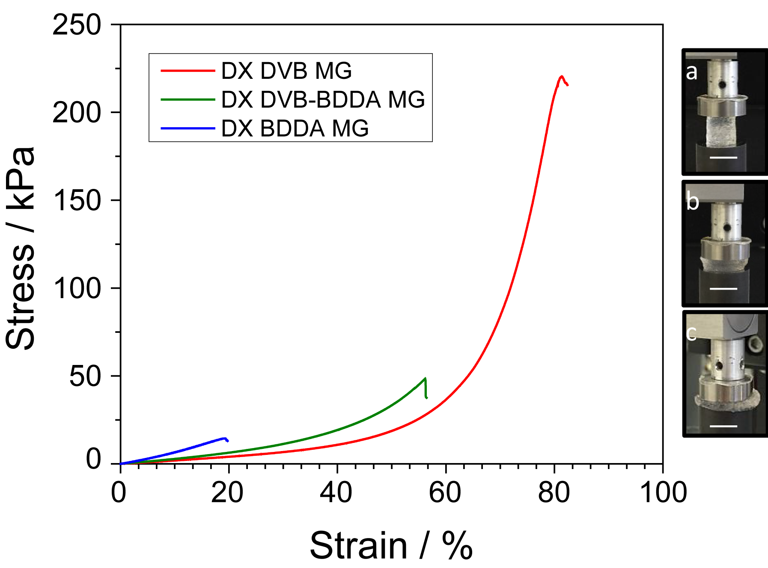

**Fig. 5.** Uniaxial compression stress vs. strain data for DX MGs prepared using various crosslinkers. The photographs show DX DVB MG compressed at different strains which were (a) 0%, (b) 40% and (c) 80%. The scale bars represent 10 mm.



**Fig. 6.** Characterisation data for the SX BDDA(0.5) MG and DX BDDA(0.5) MG. (a) hydrodynamic diameters and (b) particle volume-swelling ratios (*Q*) of SX BDDA(0.5) MG particles for a range of pH values, (c) Potentiometric titration data for SX BDDA(0.5) MG. (d) shows uniaxial compression stress vs. strain data for DX BDDA(0.5) MG.

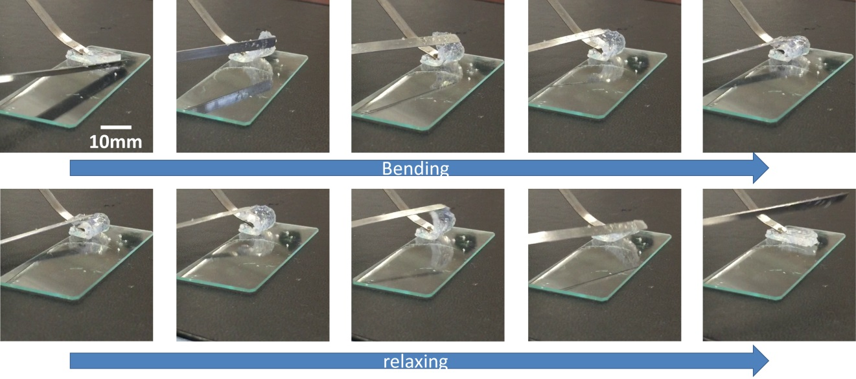

**Fig. 7**. The DX DVB MG film was tested under bending followed by relaxations cycles. The process was repeated for three times. A video is available for these sequences (See ESI†).

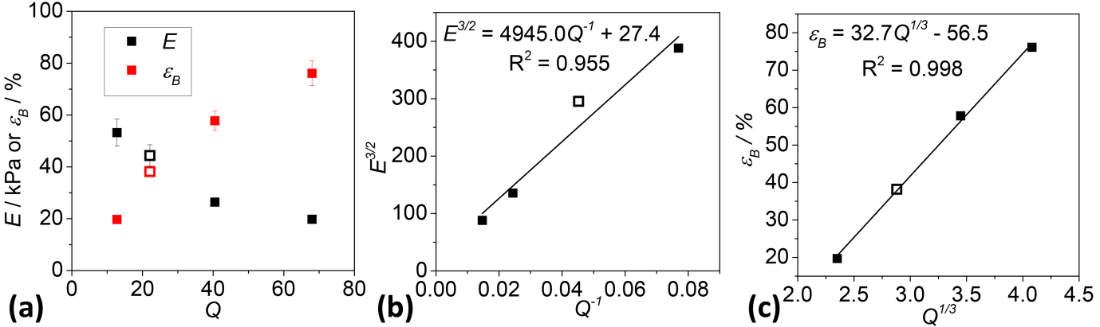

**Fig. 8.** (a) Variations of the modulus, *E*, and the strain-at-break, *B*, for the DX MGs with the MG particle swelling ratio, *Q*, for the respective parent MG particles. The data are taken from Fig. 2b and Fig. 5. (b) and (c) show the relationships between the *E* and *B* values, respectively, and *Q* plotted according to rubber elasticity theory (see text). The open symbols are the data from the SX and DX BDDA(0.5) MG systems and were obtained from Fig. S7 and Table S1. The latter data were included in the lines of best fit shown in (b) and (c).

**Table 1.** Compositions of the mixed co-monomer solutions used to synthesise the MGs

|  |  |  |  |  |
| --- | --- | --- | --- | --- |
| Abbreviation | EA  mol.% | MAA  mol.% | DVB  mol.% | BDDA  mol.% |
| SX DVB | 62.6 | 36.4 | 1.0 | 0 |
| SX DVB-BDDA | 62.6 | 36.4 | 0.5 | 0.5 |
| SX BDDA | 62.6 | 36.4 | 0 | 1.0 |
| SX BDDA(0.5) | 62.9 | 36.6 | 0 | 0.5 |

**Table 2.** Characterisation data for the MGs investigated in this work

|  |  |  |  |  |  |  |  |
| --- | --- | --- | --- | --- | --- | --- | --- |
| Abbreviation | mol.%  GMA*a* | mol. %  MAA*b* | *dn(TEM)*/ nm [CV]*c* | *dh(4)* / nm *d* | *dh(8)*/ nm *d* | *Q(8) e* | p*Kaf* |
| SX DVB | 5.3 | 32.5 | 55 [12] | 79 | 321 | 68 | 6.5 |
| SX DVB-BDDA | 8.2 | 32.4 | 57 [12] | 81 | 280 | 41 | 6.7 |
| SX BDDA | 6.3 | 31.1 | 64 [10] | 91 | 217 | 13 | 6.9 |
| SX BDDA(0.5) | 6.1 | 34.4 | 61 [13] | 82 | 230 | 22 | 6.7 |

*a* Calculated from the difference in the mol.% MAA values measured using potentiometric titration before and after GMA functionalisation. *b* MAA content after GMA functionalisation. *c* Number-average diameters determined from TEM images. The number in brackets is the coefficient of variation. *d* Hydrodynamic diameters measured at pH values of 4.0 and 8.0. *e* Volume-swelling ratio calculated from the *dh(8)* and*d(4)* values for the parent microgel using equation (1). *f* Apparent p*Ka* values. The errors (±) for these values were less than 0.1.

**Table 3.** Static uniaxial compression data for the DX MGs

|  |  |  |  |
| --- | --- | --- | --- |
| DX MG | *E* / kPa a | ** / % b | *B* / kPa c |
| DVB | 19.8 ± 1.6 c | 76.1± 4.8 | 207.1 ± 10 |
| DVB-BDDA | 26.4 ± 1.0 | 57.8 ± 3.7 | 54.0 ± 11 |
| BDDA | 53.2 ± 5.2 | 19.7 ± 0.4 | 14.5± 0.1 |
| BDDA(0.5) | 44.4 ± 4.2 | 38.2 ± 1.3 | 33.7 ± 5.1 |

*a* Calculated from the initial gradient of stress *vs* strain curves. *b,c* ** and *B* are strain-at-break and stress-at-break values, respectively.

**TOC graphic**

